How to open a PO

- Open the excel form
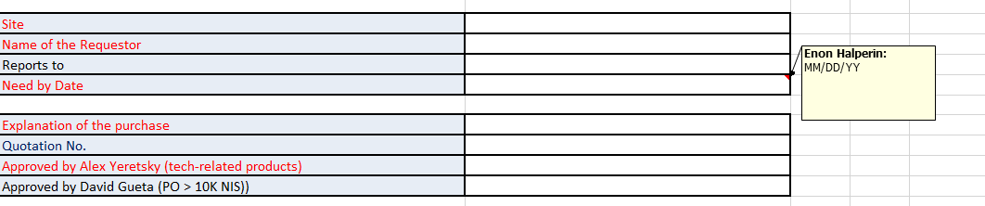
- Fill in the relevant information
8
7
6
5
4
3
2
1

- Pick the relevant site
- Choose the name of the requestor
- “Reports to“ will be picked automatically
- Choose the relevant date that you need the service/goods
- Explain the purpose of the service/goods
- If you received a quotation # pls. add it
- If Cyber Security dept. should be involved pls. choose “yes”
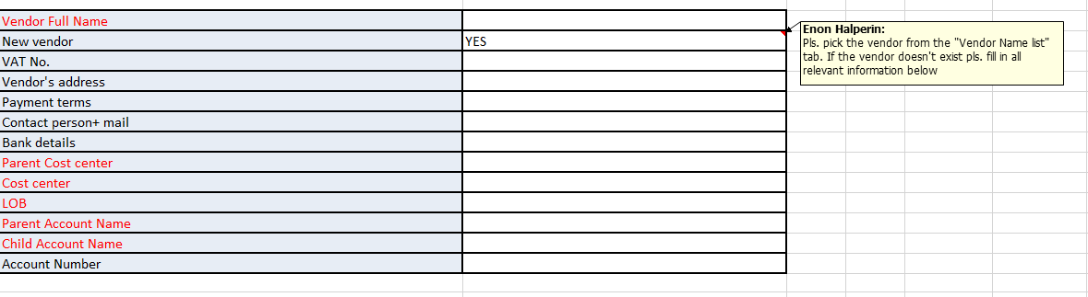
- If the PO is above 10K ILS it will be routed automatically to David Gueta
15
14
13
12
11
10
9
- Pls. choose the Vendor from the “Vendor Name list” tab. If the vendor is new follow the instructions in the “new vendor instructions” tab
- Pick the parent cost center from the list
- Pick the cost center from the list (only relevant cost centers from the parent cost center that was picked will be displayed)
- Pls. choose the relevant LOB (line of Business): Unattended, Retail, EV etc..
- Pls. choose the relevant parent account category (ie: Marketing, computers etc.)
- Pls. choose the relevant account (only accounts that are part of the parent account will be displayed)
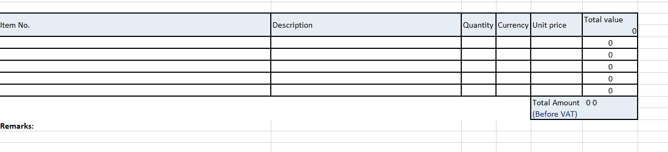
- Account Number will be displayed automatically
18
17
16
- Write the relevant descriptions for every cost of service/goods
- Pick the relevant quantities. For service if you are requesting hours pls. choose the number of hours and in the unit price pick the hourly rate
- Pick the relevant currency that will be used
- Once done press the “send PO for approval” blue button and send the email
- The email will be sent automatically to the FP&A team
- The FP&A team will check if there is a budget and approve. The PO will be sent to the requestor manager based on the DOA (delegation of authority).
- The Manager will approve and send back to the FP&A team.
- The FP&A team will send the PO to the Purchasing dept. that will enter the data in SAP and send the PO to the vendor

